**PO1_DGC_Digital Calculator**

**CYRS Document**

**Version 1.2**

**Proposed**

|  |  |  |  |  |
| --- | --- | --- | --- | --- |
| **Document Change History** | | | | |
| **Version** | **Author** | **Date** | **Change** | **Status** |
| 1.0 | - Alzahraa Mohamed  - Nada Mohamed | 22/1/2020 | * Initial creation | Draft |
| 1.1 | - Alzahraa Mohamed  - Nada Mohamed | 30/1/2020 | * Specifying only one button for powering calculator instead of two buttons in Req_PO1_DGC_CYRS_005_V01 * Change in system scenario diagram, adding powering button. * Explaining the type of input numbers that calculator accepts floating numbers in Req_PO1_DGC_CYRS_001_V01 * Explaining the error message that displays on wrong input in Req_PO1_DGC_CYRS_003_V01 * Specifying the styling of displaying operation and result on LCD on two separated lines in Req_PO1_DGC_CYRS_004_V01 | Proposed |
| 1.2 | - Alzahraa Mohamed | 5/2/2020 | * Changes in styling format. * Editing the description of Req_PO1_DGC_CYRS_005_V01 * Change the document status from “Draft” to “Proposed” | Released |

**Table of Contents**

1 Project Description 5

1.1 Features 6

2 Features description 7

**Index of Figures**

Figure ‎1‑1 System Scenario Diagram 5

# **Project Description**

This project is a digital calculator that takes input from user and displays the input and the result on a screen.

The hardware used in the calculator is Keypad which takes input from user, LCD to display the result, buzzer to generate tunes on each key press and micro controller that performs all operations in the system. The scenario is described in Figure ‎1‑1

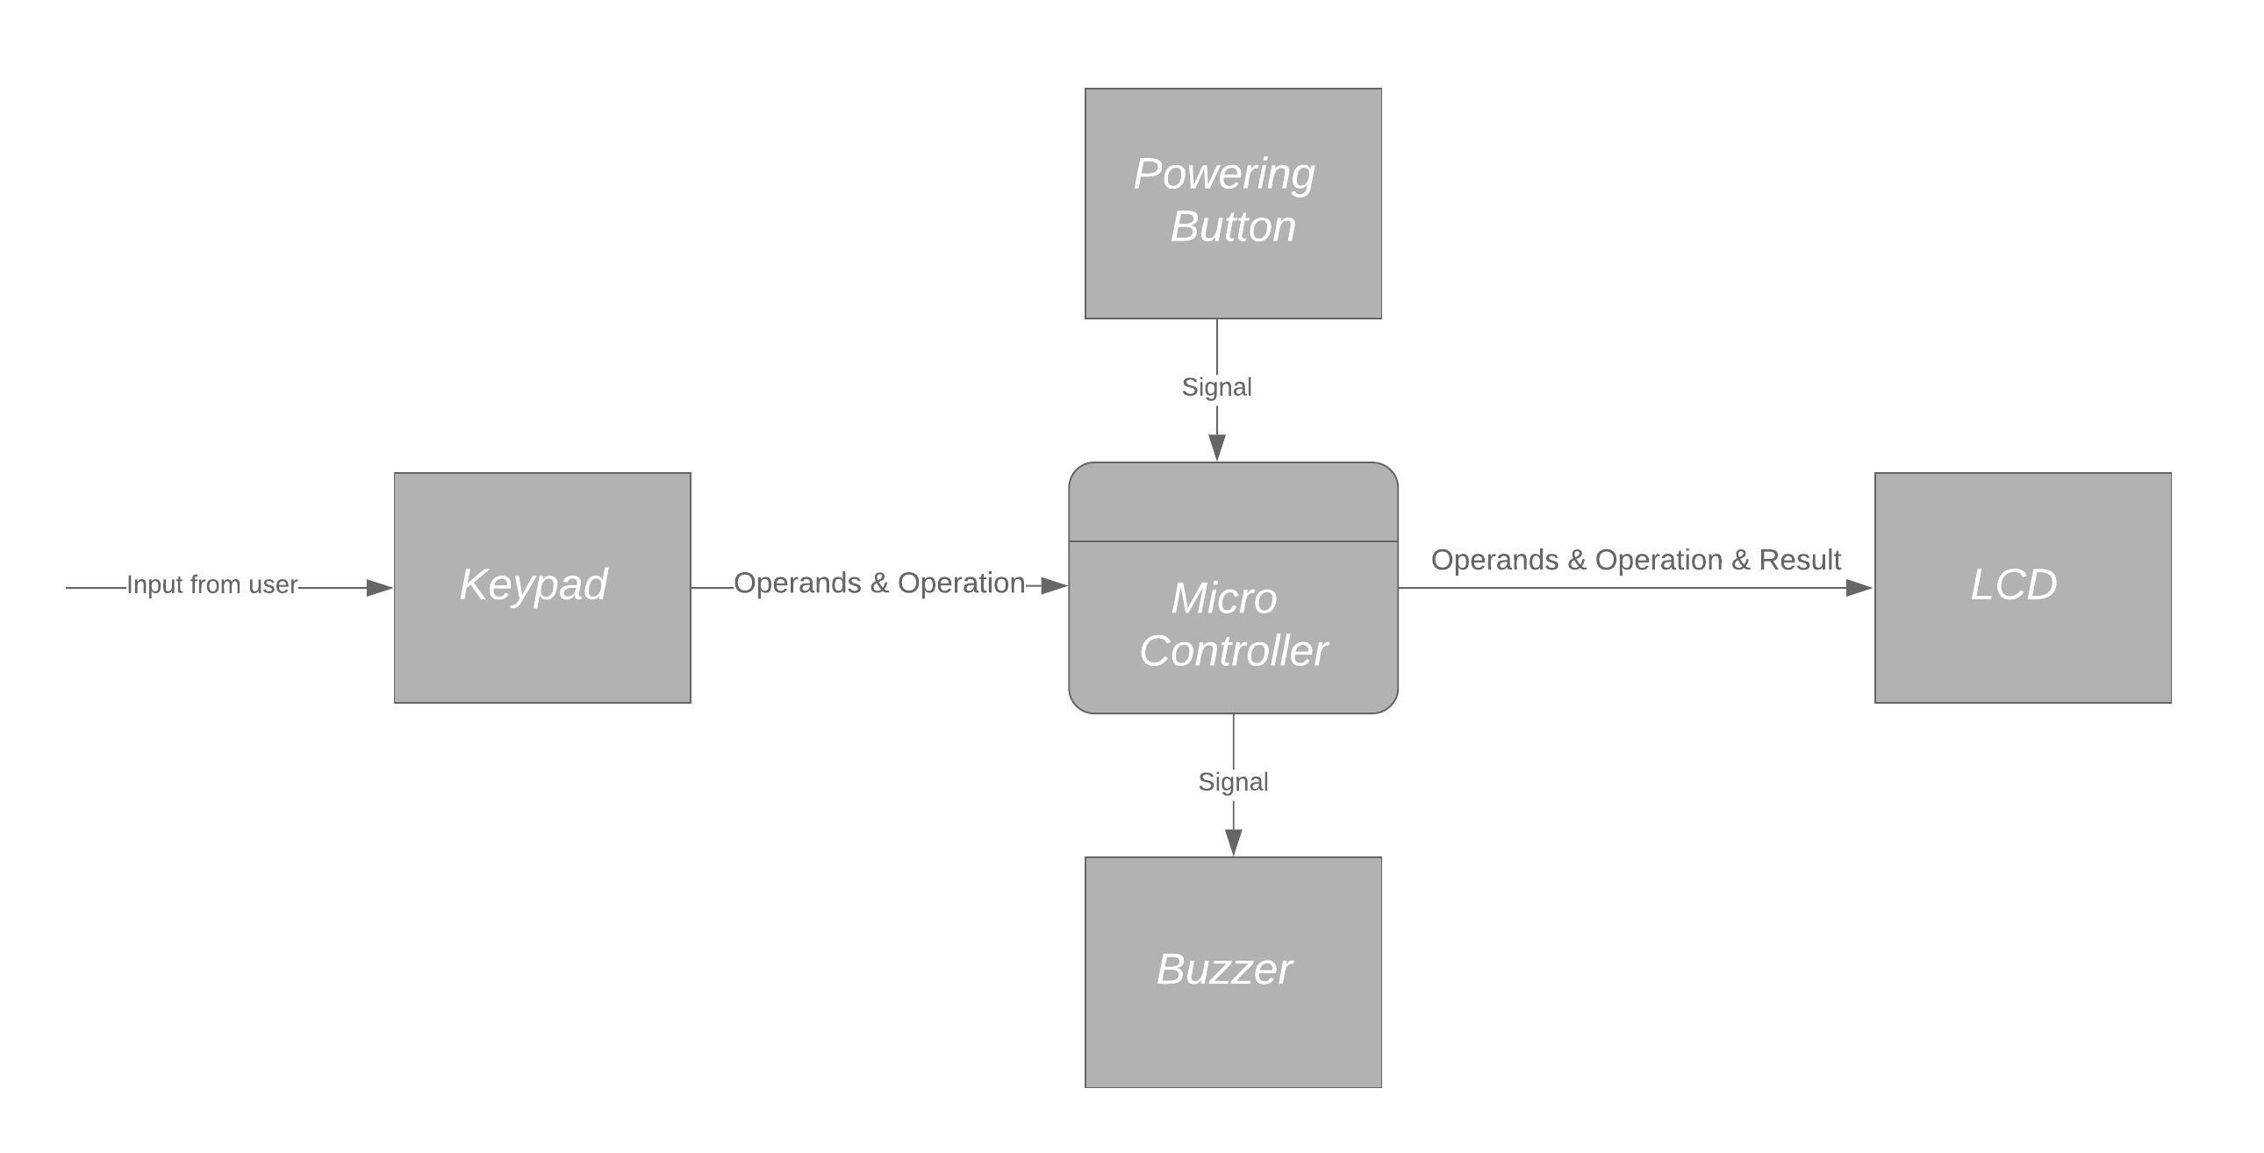

Figure ‎1‑1 System Scenario Diagram

## **Features**

1. Takes input from user through keypad.
2. Generates a tune on each key press.
3. Performs multiple basic operations and handle corner cases.
4. Displays the input and the result on LCD.
5. Switching calculator on and off.

# **Features description**

|  |  |
| --- | --- |
| Requirement Name | Requirement Description |
| Req_PO1_DGC_CYRS_001_V01 | Calculator takes input from user through keypad, on each keypress number is sent to micro controller. The number could be decimal or floating number up to 2 digits after the point. |
| Req_PO1_DGC_CYRS_002_V01 | Micro controller sends signal to buzzer on each key press to generate tunes. |
| Req_PO1_DGC_CYRS_003_V01 | Micro controller performs basic operations which are addition, subtraction, division and multiplication on numbers token from keypad and handles exceptional cases such as division by zero and generates the accurate result or an error if it is required as an error message: “ERR: wrong input”. |
| Req_PO1_DGC_CYRS_004_V01 | Micro controller sends input numbers, operation and generated result to be displayed on LCD on two separated lines, first line for input operation and second line for the result. |
| Req_PO1_DGC_CYRS_005_V01 | The calculator is switched on and off through one button. On state turns the LCD light on, clears the display and start a new session, while off state turns the LCD light off and terminates the session. |